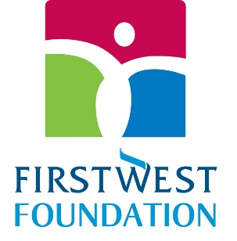

Envision Financial Employees’ Endowment Awards $27K in Grants

$3,000 – Cyrus Centre | Chilliwack
https://www.cyruscentre.com/
$3,000 – Fraser Region Aboriginal Friendship Centre Association
https://frafca.org/
$3,000 – Emotions Health & Wellness Society of BC | Lower Mainland
https://emotionsbc.ca/index.html

$2,500 – SOS Children’s Village BC
https://www.sosbc.org/

$2,000 – Chilliwack Bowls of Hope Society
https://chilliwackbowlsofhope.com/

$2,000 – Ann Davis Transition Society
https://www.anndavis.org/

$2,000 – Friends in Need Food Bank
https://friendsneedfood.com/

$2,000 – Abbotsford Archway Food Bank
https://www.abbotsfordfoodbank.com/

$2,000 – Ishtar Women’s Resource Society
https://ishtarsociety.org/

$1,750 – Langley Animal Protection Society (LAPS)
https://www.lapsbc.ca/

$1,250 – The Board of Education of SD#35 | North Otter Elementary School
https://northotter.sd35.bc.ca/

$1,000 – Buddhist Vihara Society in BC
https://www.bvs.org/

$750 – Amici Curiae Friendship Society
https://www.legalformsbc.ca/
$750 – Chilliwack Animal Safe Haven
https://www.chilliwacksafehaven.com/

